MGM COLLEGE FIRST GRADUATION DAY ON 2/4/2022
Mar Gregorios Memorial (MGM) College conducted its first graduation ceremony for the graduate batches of 2017-20 and 2018-21 on 2nd April in the College auditorium. A total of 92 students graduated in BA General and Honours from the departments of English, Political Science, Sociology and Education.
The event commenced with the Bible reading and invocation by Ms.Tolivi Sumi, Asst.Professor, Dept.of English followed by welcome address by the Principal of MGM College, Rev.Fr.Dr.P.S.Varghese.
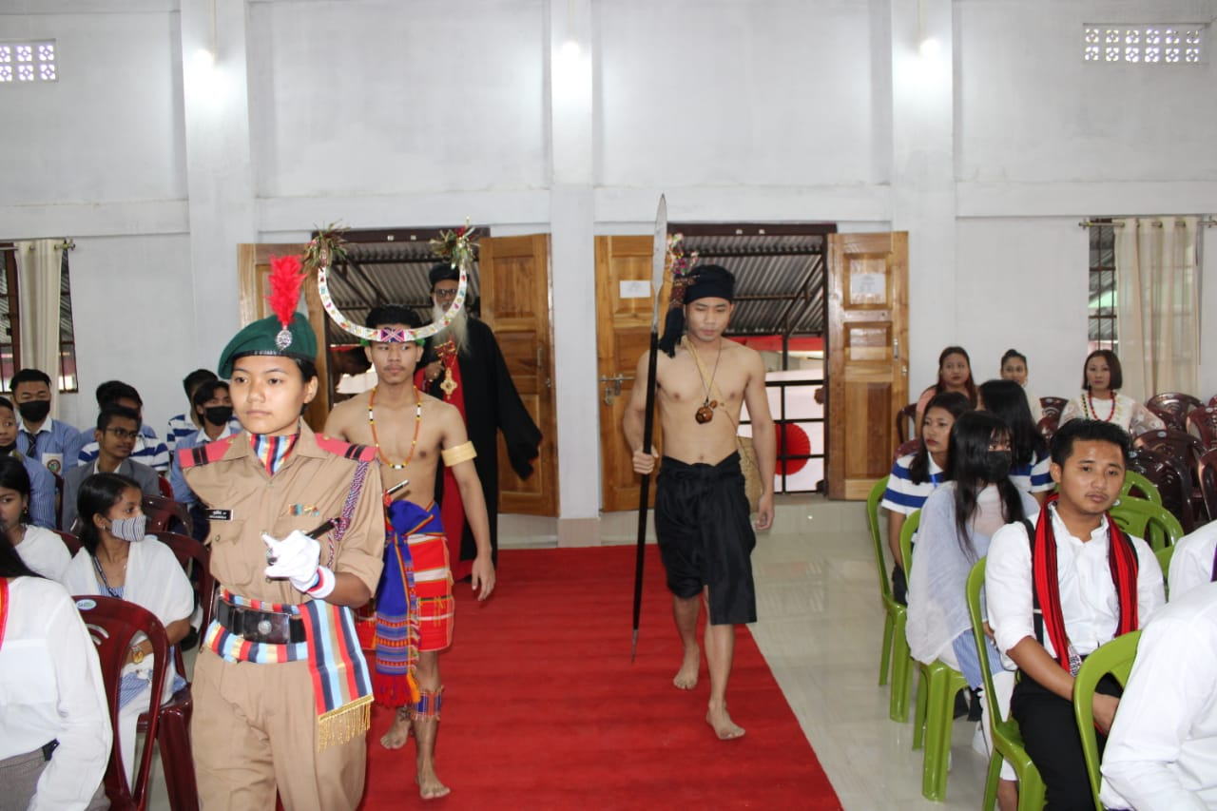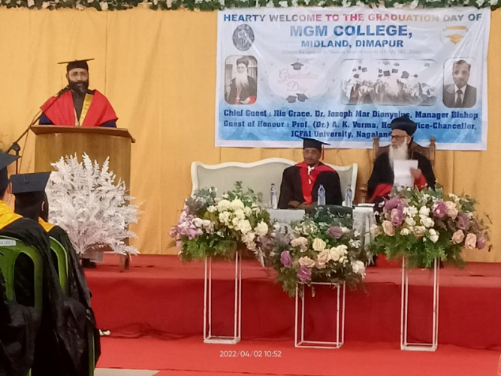
In the welcome speech the principal briefed the history of MGM institutions in Nagaland. This particular college was established in the year, 2016 as the diamond jubilee birthday celebration of Diocesan Bishop, His Grace Dr.Joseph Mar Dionysius.
The principal further mentioned that although the plan was to conduct the graduation ceremony of the first two batches earlier; it wasn't possible due to the pandemic. "There is a time for everything, better late than never." He reminded the gathering.
In his address the Director and Manager Bishop His Grace, Dr.Joseph Mar Dionysius, the Chief Guest recalled the mercy of God to start a college with limited resources and appreciated the committed team work under the leadership of the principal and Governing Body.
Special Guest of the event Dr.Arun Kumar Verma, Hon'ble Vice-Chancellor of ICFAI University, Nagaland reminded the audience that education is a lifelong process and as a need towards collaborative learning, we need to have a sense of empathy and social responsibility, which will further make our education beneficial for the society.
Toppers of the batches of 2017-20 and 2018-21, Ms.Limatula Aier and Ms.Akung respectively, were awarded with Mar Theodosius meritorious trophy and Joseph Mar Dionysius meritorious cash awards. This was followed by the felicitation of the semester toppers for the year of 2021. The special award of Late.Ms.Priyanka Ganta scholarship for second semester toppers of the years 2020 and 2021 was awarded to Mr Anoto and Miss Thenjano respectively.
Altogether 57 students were awarded with certificates. Currently the college is offering BA general and Honours in English, Pol.Science, Education, Sociology, History and Economics along with B.Com general and Honours in Accountancy and Management.
Special number was performed by Mr.Wipezo 6th semester, Pol.Science and vote of thanks by Mrs. Durga Malarkar, Vice-Principal. Mr.David,Asst.Professor, Dept.of History and Ms.Smaranika,Asst Professor Dept.of English were the comparers of the program.

