UNIVERSITY INSPECTION REPORT
Dimapur : An inspection team from Nagaland University visited MGM College on 16th March 2020. The main purpose of visit was for renewal of affiliation of the college under Nagaland University(notification: NU-CDC/C-72/2014(Pt-1)-7642 dated 7/2/2020). The esteemed members Prof. Dr. Rakesh Rai, Dr. Md. Aktar Jamal and Dr. Likhase Sangtam inspected the infrastructure and facilities at the campus especially the Classrooms and the Library.
Thereafter the Principal Fr.Dr.Shibu Varghese, Vice Principal Mrs.Durga Malakar and all the faculty members had an interactive session with the members.
The members stressed on the importance of pursuing PhD degree for the teaching faculty, importance of publications and induction program courses for teachers.
The inspection team suggested the following points:
1. To purchase more land for the college
2. Complete infrastructure before the next academic session
3. Minimum salary 21,600/ for eligible faculty members (NET/PhD), an undertaking has taken from the principle to pay out from March 2020.
4. To buy more books and journals for library
5. To appoint minimum 3 faculties for honours subjects
The inspection program ended with a scrumptious Lunch which was followed by a photo session.
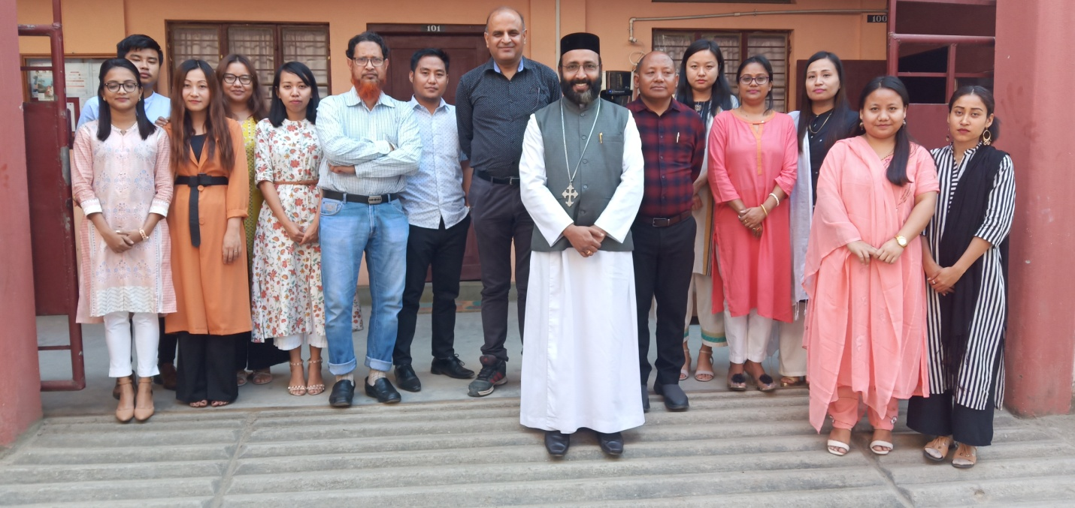
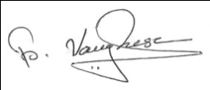
Fr.Dr.Shibu Varghese
Principal

