REPORT ON PARIKSHA PE CHARCHA 2.0
The students of M.G.M College,Midand,Dimapur attended the live telecast of Hon’ble P.M Narendra Modi’s interactive session titled “Pariksha Pe Charcha 2.0” on dated 29th January,2019 held at the College library and computer lab.
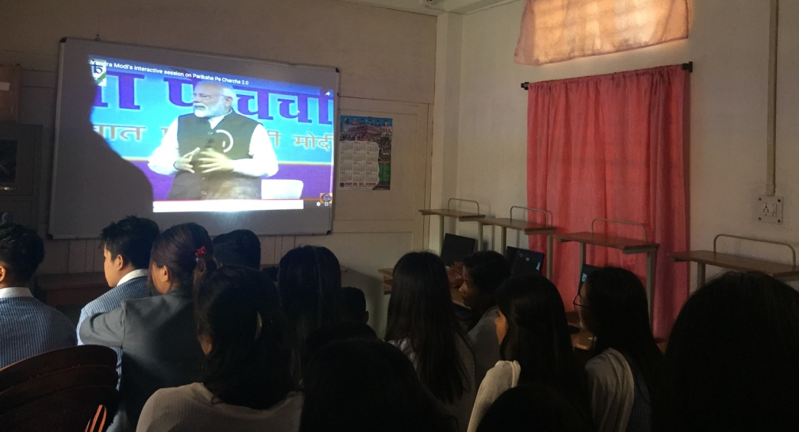
During the interactive session he discussed on the issue of stress free examination and encouraged the students to take exams as an opportunity. He also spoke about the need for proper time management and advised the students to focus on their aim. Altogether, 57 students from BA 2nd semester and 32 students from BA 4th semester and 14 faculties along with college Principal,Fr.Dr.Shibu Varghese and Vice Principal Mrs.Durga Malarkar attended the said programme. The session ended with light refreshment.
