MGM COLLEGE CONDUCTED 2ND ANNUAL SPORTS
Dimapur: MGM College, Midland, Dimapur celebrated 2nd Annual Sports week from December 5th to 7th. On 5th the sports week was inaugurated by Principal Fr.Dr.Shibu Varghese. On 6th Indoor items conducted at College and MGMHSS.
3rd days programs were began with sack races for both boys and girls followed by football finals(boys)Volleyball final, tug of war (co-ed), all athletic items etc.
Closing ceremony began at 2:00 p.m with Col. Mukesh Kumar (Director Works SEWAK) as the chief guest.
In the closing day ceremony Principal welcomed the guests and stressed on the importance of holistic development for all students. It was followed by a song and prize distribution by the chief guest.
Col. Mukesh Kumar gave a speech highlighting the importance of sports in a person’s life by saying that sports helps in teaching values such as team spirit and time management. The programme ended with the National Anthem and lowering of the flag by the chief guest . Yellow house was placed in the first position followed by Red, Green and Blue House respectively.

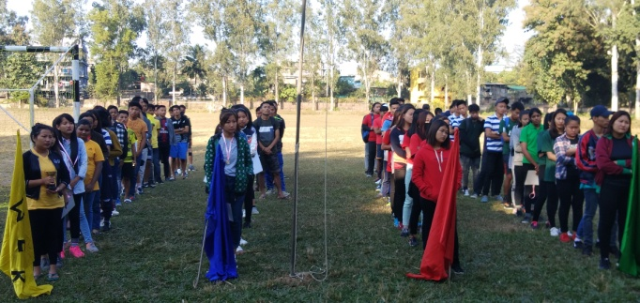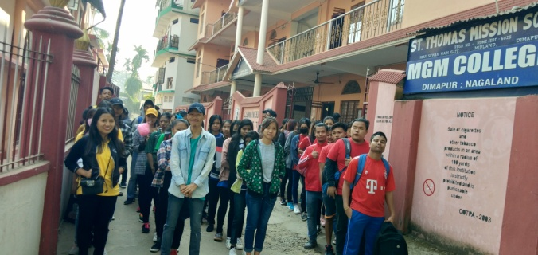
4 Houses on the day of Inauguration Ready to go to SEWAK ground
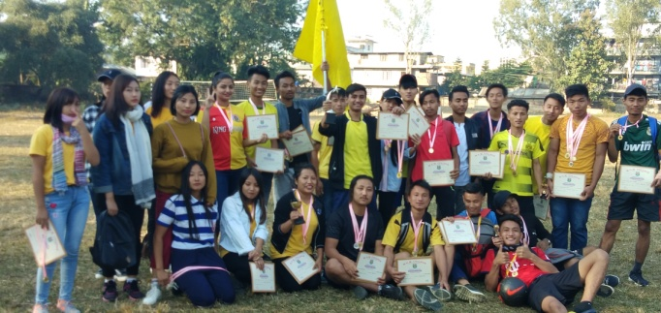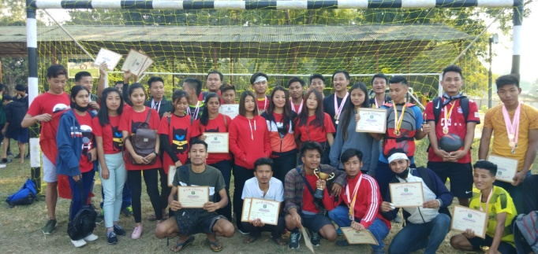
Winners- Yellow House Runners up –Red House
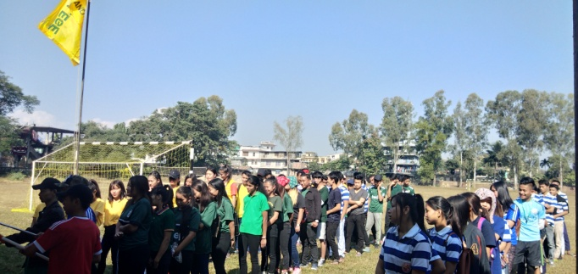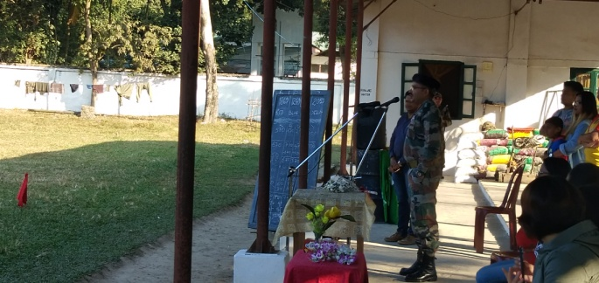
Flag Hoisting Col. Mukesh Kumar Chief Guest, SEWAK

