INDO GLOBAL EDUCATION EXCELLENCE AWARD CONFERRED TO FR.DR.SHIBU VARGHESE AND MRS.NIMMI VARGHESE FOR THEIR OUTSTANDING CONTRIBUTIONS TO THE FIELD OF EDUCATION.

Bangkok : June 6th:
The Indo Global Multidisciplinary Educational Conference (IGMEC2019)held at Bangkok, Thailand from June 1st to 4th. The conference was hosted by International Benovalent Research Foundation (IBRF),in association with Confederation of Indian Universities (CIU), New Delhi, Commonwealth society for innovation and research along with Commonwealth vocational university,Tonga, to provide a global platform for academicians, researchers, practitioners and policy makers.

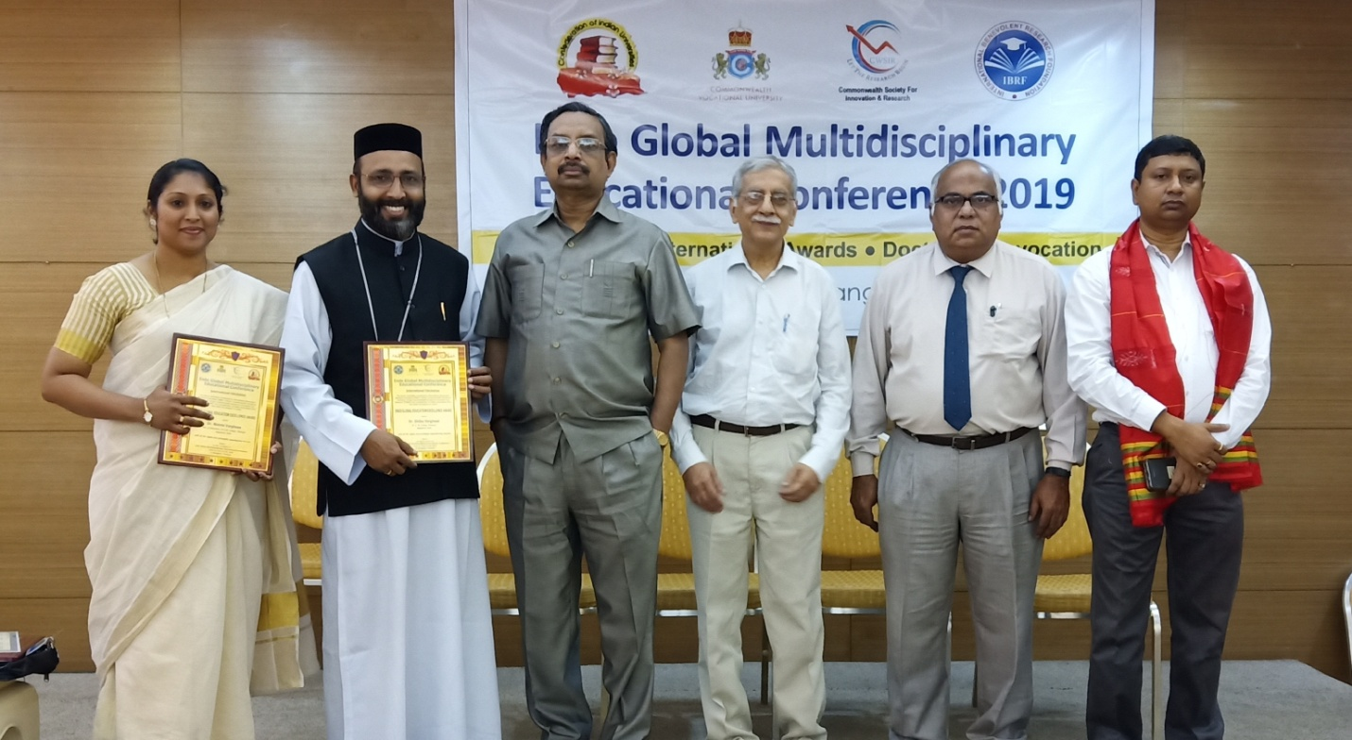

From Nagaland Rev.Fr.Dr.Shibu Varghese, Principal of MGM College, Dimapur and Mrs. Nimmi Varghese, Dept.of Education,MGM College, participated and presented papers on 'Ancient Indian Education system and Gandhian precepts of Holistic education' and 'Women's empowerment in india with Gandhian perspective'. Later the duo were awarded with Indo Global Education Excellence Award for their outstanding contributions to education and for their innovative ideas in Higher secondary and Higher Education.

In the three day multidisciplinary conference more than 30 papers were presented and the same were published as a Book of Abstracts and Full papers during the conference.

