MGM COLLEGE & MGM HR SEC SCHOOL
UNDER THE AEGIS OF ST.THOMAS MISSION SOCIETY (HOME/SRC-6028)&
MGOS CHURCH, MIDLAND.
M.G.M. COLLEGE, Dimapur congratulates Dr.Kavika .K. Yepthomi D/o Mr. S.Kahovi Yepthomi & Mrs K. Arenla Imchen and W/o Mr.Inakavi .I .Ayemi for successfully completing Ph.D in Economics on the Topic “An Economic Analysis of Organic and Inorganic Rice Farming in Dimapur District, Nagaland: A case study” from Pondicherry Central University.
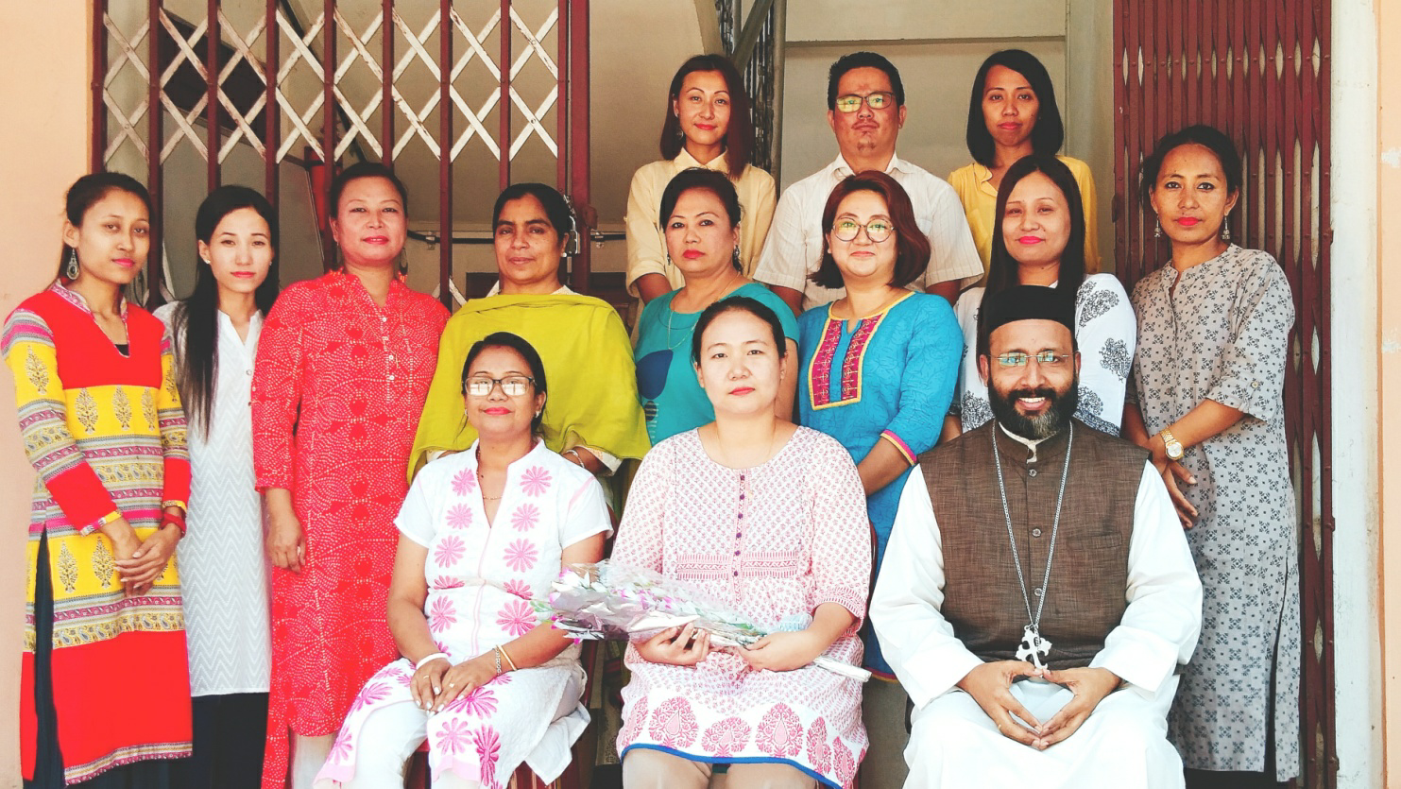 Congratulations Dr.Kavika .K. Yepthomi
ADMISSION STARTED FOR CLASS 11-ARTS, COMMERCE & SCIENCE FROM 19/5/18.
B.A (GEN) & Honours in Political Science, Education, Sociology & English.
Classes will commence from 30/5/2018.
SALIENT FEATURES OF MGM INSTITUTIONS
- Bishop Mar Theodosius Memorial (MTM) full Scholarship for students scoring 85% and above.
- Well qualified and experienced Teachers.
- Free education for Rank holders and School Toppers .
- Admission on first come first serve basis .
- Hostel facility available for girls.
- Admission will close on 25/5/18.
- 50% Concession on admission fees for MGMHSS students to purse in B.A for first two semesters.
- Late K.V.Ponnan Meritorious Scholarship for Semester toppers.

